How to Create an Unplanned Discharge without a
Completed Assessment In NRS

- Go to E-Assessments ---> NRS.
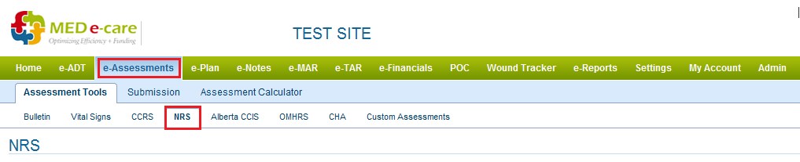
- Scroll to the Bottom and Click “ Start an Unscheduled Assesment ”.
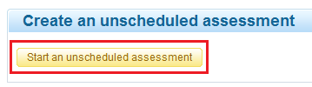

- Select the Resident from List.
- Select Assessment Option as “Admission”.

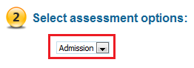
- Click Create the Assessment.

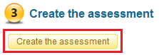

- Enter ARD and Select “Un-planned Discharge without Assesment” from Admission Class drop down menu.
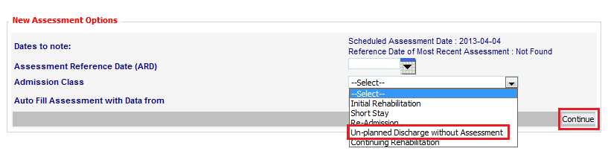
- Click Continue and complete the assessment.

